TEST EXECUTION (LEVEL 3)
- Test Runs
- Creating Test Runs
- Test Execution Statuses
- Executing Test Cases
- Adding Comments & Execution Notes
- Time Tracking during Execution

1. Test Runs :
A Test Run is an execution instance of test cases. It is Test cases + execution results for a specific build / version.
Test Case → design (static)
Test Run → execution (dynamic)
We can execute the same test case multiple times across:
- Builds
- Environments
- Releases

A Test Run Contains :
- Selected test cases
- Execution status
- Tester name
- Comments
- Time spent
- Defect links

Creating Test Runs :
We create testcases when new build received, Regression cycle starts, Sanity testing, UAT execution. A test run represents testing activity for a specific build or release.

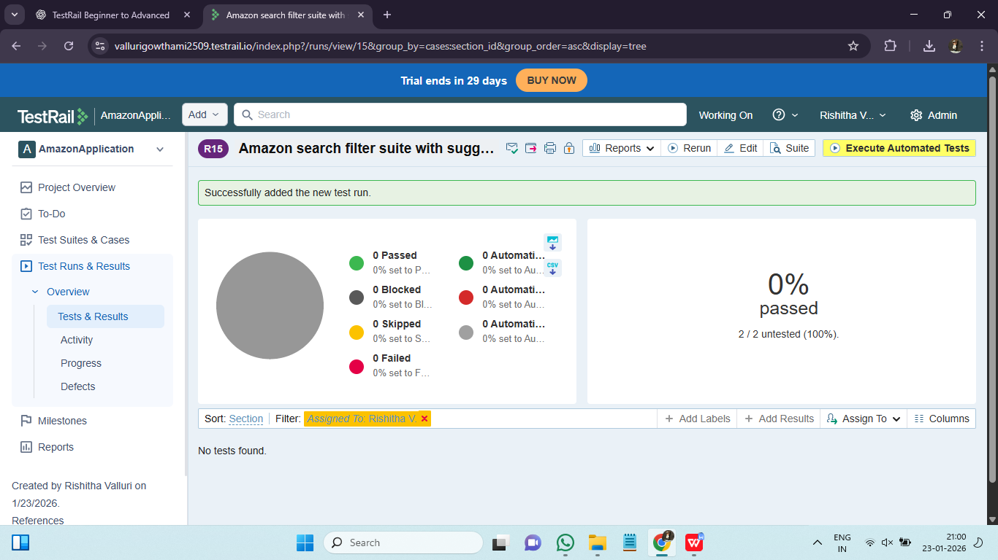

Test Execution Statuses :

Status | When to Use
Untested | Not executed yet
Passed | Expected = Actual
Failed | Mismatch
Blocked | Cannot test (dependency issue)
Retest | Fix provided, needs re-check

Executing Test Cases :
Execution Flow :
Open test → Perform steps → Compare result → Mark status → Add notes → Save
Execution is evidence-based, not assumption-based.

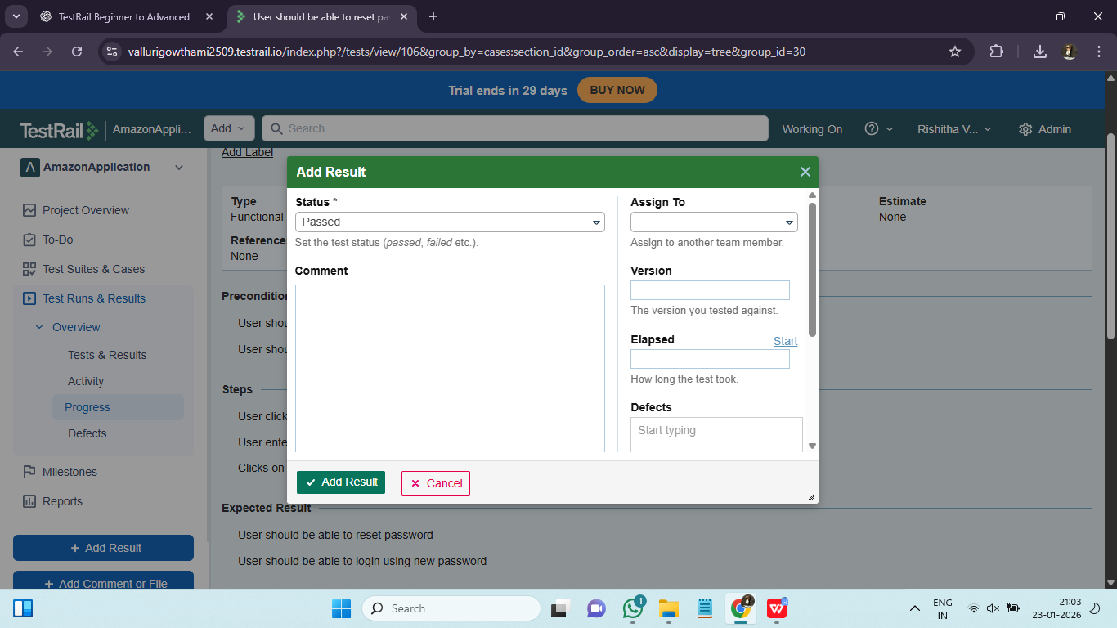

5. Adding Comments & Execution Notes :
Comments explain:
- What exactly failed
- What was observed
- Why test was blocked

What to Add in Comments
- Actual result
- Error messages
- Screenshots
- Defect ID

Good comments reduce defect triage discussions by 50%+. Execution comments act as living documentation for defects and audits.

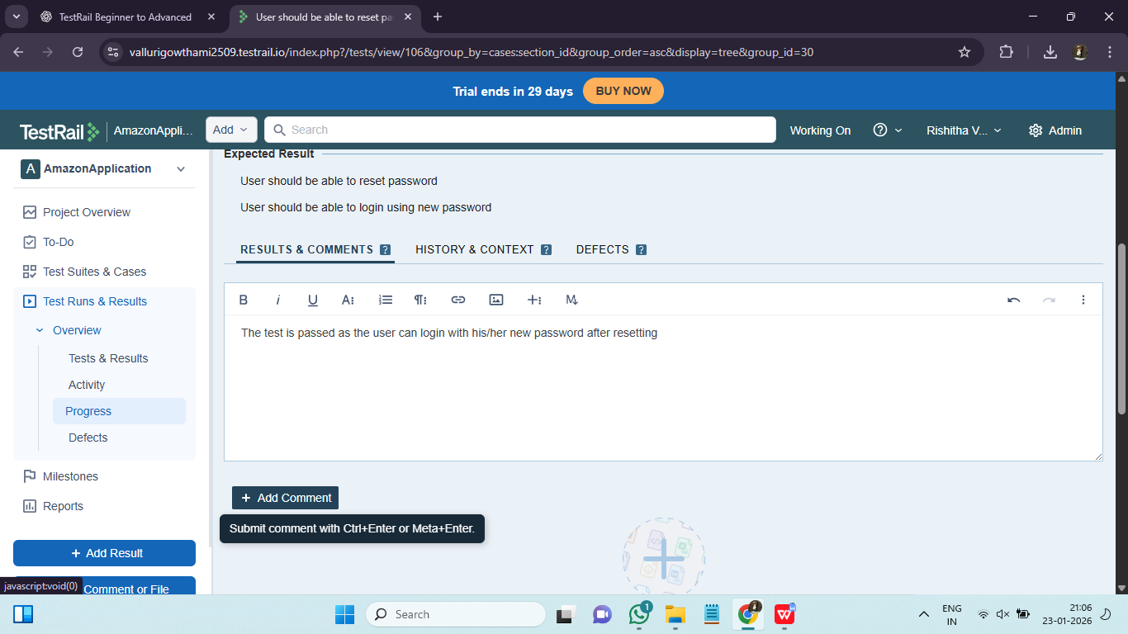

6. Time Tracking during Execution :
Time Tracking is Tracking actual effort spent on test execution. It is important because of :
- Effort estimation
- Release planning
- Productivity analysis
- Cost justification

